Students’ Handout MVC

Welcome to the MVC in ASP.NET Core training session on creating a job portal application! This handout provides guidelines for students on how to approach the material, participate in workshops, and complete exercises. This Topic Includes Creating View ,Controller ,Dependency Injections and other functionalities..

In The Joseeker Controller.. To List JobApplications..Of that User

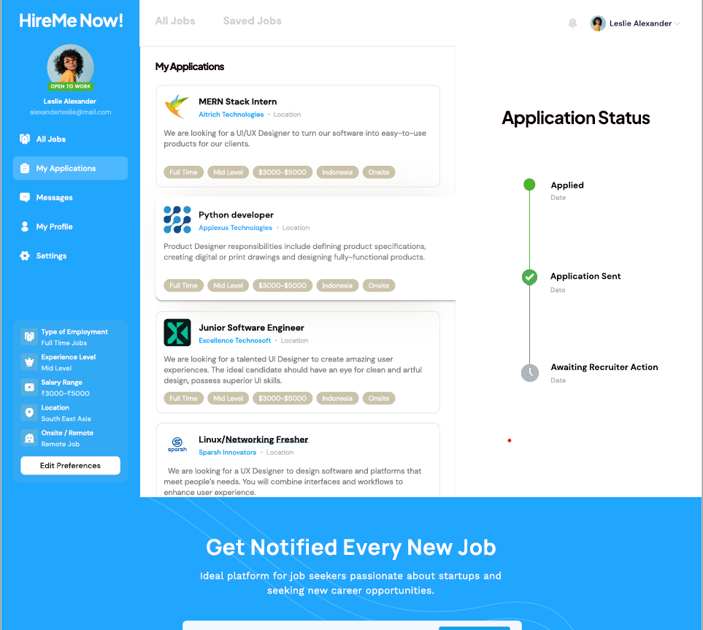

Create A Job Provider Controller ..And create a view for display all applications…schedule interviews for the applications and display scheduled interview list….

Design Screen to display All Applications and on button click we can schedule interview for that job..

SheduledInterviewList

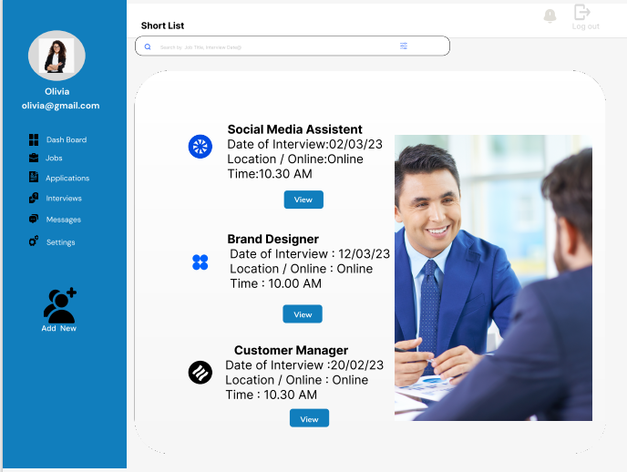

Shedule Interview

